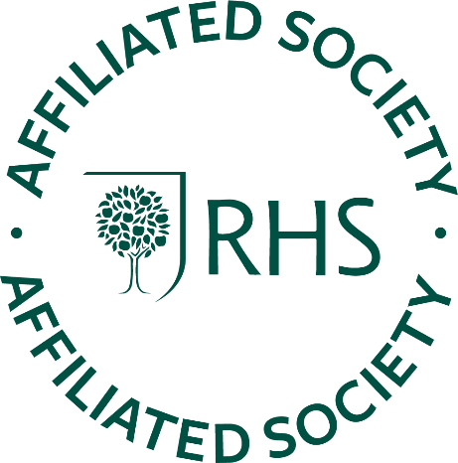
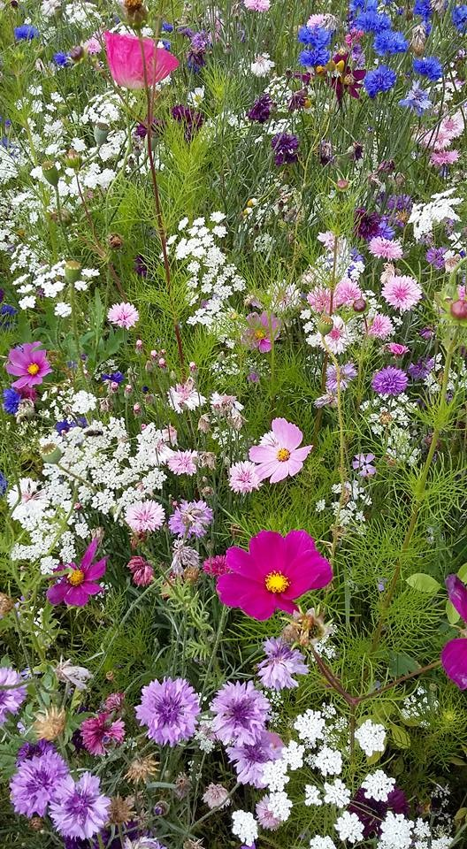
A big warm hello to all our Affiliated Societies
I hope you are all safe and well. It’s such a difficult time social distancing and trying to maintain some semblance of normality. Are you and your gardening friends managing to keep in touch? Have you or anyone in your group come up with any fun ideas to keep morale up? I am intending sending regular notes to you to keep you up to date with RHS news, but it would be great to hear from you too. Tell me about any fun ideas you have and what you are doing to reach out to your community. As always send everything to affiliated@rhs.org.uk

At the RHS we are continuing to support our communities as best we can. If you would like to contact us about any aspect of your affiliation please email affililated@rhs.org.uk Please don’t phone as picking up messages can be a problem and we don’t want to miss anything important.

If you, or anyone you know, give garden based talks and have either got a link to pre-recorded talks, or can deliver a ‘live’ talk via Zoom please let me know. If I can get a few together I will forward details. It might be fun to tune in to a cosy talk on behind the scenes at a famous garden or what it is like to work at Chelsea, or interesting planters.

Sadly, all our events up until the end of June have been cancelled, an unprecedented situation, but do look out for information about other initiatives to be announced later.
Stay safe, Susie

